**DEVELOPMENT OF MAMBYAHE: A WEB-BASED RIDE-SHARING APPLICATION FOR TRICYCLE DRIVERS AND COMMUTERS IN**

**MAMBURAO, OCCIDENTAL MINDORO**

**AN UNDERGRADUATE RESEARCH PROJECT**

Submitted to the Faculty of Bachelor of Science in Information Technology

**OCCIDENTAL MINDORO STATE COLLEGE**

Mamburao Campus

As Partial Fulfillment of the Requirements for the Degree

**BACHELOR OF SCIENCE IN INFORMATION TECHNOLOGY**

**JUSTINE KURT E. CUSTODIO**

**MARY GRACE V. COMESO**

**JEN C. FULGENCIO**

**JESUS RUBION**

**ANDREA D. SARSABA**

**NATHANNIEL R. UCOL**

Date Submitted:

**May 8, 2025**

|  |  |  |
| --- | --- | --- |
| **TABLE OF CONTENTS** | | |
|  | | |
|  | | **Page** |
| **TITLE PAGE** | | **i** |
| **TABLE OF CONTENTS** | | **ii** |
|  | | |
| **CHAPTER** | | |
|  | | |
| **I** | **BACKGROUND OF THE STUDY** | **1** |
|  | Introduction | 1 |
|  | Objectives of the Study | 4 |
|  | Significance of the Study | 4 |
|  | Conceptual Framework of the Study | 6 |
|  | Scope and Limitations of the Study | 8 |
|  | | |
| **II** | **REVIEW OF THE RELATED LITERATURE AND STUDIES** | 9 |
|  | | |
| **III** | **METHODOLOGY** | 25 |
|  | Project Design | 25 |
|  | Project Development | 27 |
|  | Operational and Testing Procedure | 29 |
|  | Project Structure | 32 |
|  | | |
| **REFERENCES** | | 48 |
|  | | |

### **CHAPTER I**

### **BACKGROUND OF THE STUDY**

**Introduction**

Transportation is a basic need in every community, as it helps people get to where they need to go easily and on time. In Mamburao, Occidental Mindoro, tricycles are the go-to choice for short trips. Many locals rely on tricycles regularly, whether it is for going to work, school, the market, or other important places. However, finding a tricycle can be a hassle, especially during peak hours or in more remote Barangays. As the population keeps growing, there is a corresponding increase in the number of passengers who need immediate public transport, hence the need for efficient and reliable transit systems. Tricycle transport enables people to travel long distances without feeling tired or wasting time, therefore making it an excellent option for people who need quick and efficient travel. In addition, tricycle drivers gain significant economic benefits from this mode of transport, as it gives them a constant source of income that feeds their families and supports the local economy.

Among the numerous factors that enable the existence of light in modern society, technology stands out as the most dominant. With the fast-changing world today, technology is the driving force to advancing our daily lives, providing us with convenient and efficient access to resources needed. People use smartphones and apps for all sorts of things chatting, shopping, and getting around. Ride-sharing apps have become popular in cities because they offer a quicker, more convenient way to book rides. However, in smaller towns like Mamburao, the transportation system is still quite traditional and manual. The 2020 census shows that Mamburao has around 11,162 households and a population of 47,705, thus a strong community relying mainly on public transport (Population and Housing | Philippine Statistics Authority | Republic of the Philippines, 2021). According to the PSA, only about 1,116 people, or 10% of the total population, own a vehicle in Mamburao, thus the vast reliance on tricycles and other public transport by a greater number of the populace. This fact attests to the great importance of improving and maintaining public transport systems to cater to a growing population effectively.

One of the biggest challenges faced by the residents of Mamburao who do not own vehicles is commuting. The people of Mamburao have grown accustomed to traditional practices, such as walking several meters just to reach the designated areas where vehicles are available, and spending additional minutes—sometimes even hours—waiting for passing transportation. In some regions of the province, the timely availability of vehicles may be severe. Rural communities typically have a bad quality of service in public transport because of the high cost of maintaining an effective frequency and extensive coverage, as the demand density is low (Sergei Dytckov et al., 2022). Recent studies by Kim et al. (2023) highlight the factors affecting vehicle availability, which are closely linked to waiting times, and emphasize the need for measures to address waiting time issues, especially for persons with disabilities and senior citizens. This situation is exacerbated by inadequate access and the lack of interconnectivity between various transport modes, making it increasingly challenging for commuters to reach their final destinations (Chang et al., 2021).

Research conducted by Garcia (2019) shows that travelers frequently experience frustration due to inefficient services, whereby long waiting times have an adverse impact on their general journey experience and well-being. It is hence critical to prioritize high improvement of availability. Further, research comparing conventional commuting modes with contemporary methods highlights the central role played by effective scheduling. Inadequate reliable modes of transportation can go a significant distance in discouraging individuals from performing their day-to-day obligations, leading to heightened dissatisfaction and reduced productivity (Suthers, 2017).

To help bridge this gap, the researchers are proposing Mambyahe, a web-based ride-sharing app specifically for Mamburao: a web-based application specifically designed to streamline and enhance the ride-hailing experience for both tricycle drivers and local commuters. This innovative ride-sharing platform features electronic ride logging, providing a user-friendly space for efficient trip coordination, real-time updates, and improved communication between drivers and passengers. It allows commuters to book rides directly from their phones, while drivers can easily receive ride requests and connect with passengers. The goal is to simplify transportation, reduce wait times, and create a safer, more reliable way for everyone to travel. The platform includes features in similar ride-sharing applications, such as user registration for seamless onboarding, a comprehensive dashboard for easy access to key functionalities, and notifications for real-time updates and reminders. It also allows access control through user profiles, enabling users to modify their personal information for greater customization.

This study emphasizes the importance of promoting real-time collaboration between commuters and drivers, transparent information sharing, trip tracking, and an improved user experience through an intuitive interface. The initiative aims to foster transparency and immediate availability within the local driver community by ensuring real-time updates, clear communication, and equal access to ride requests, enabling drivers to respond promptly and efficiently to commuter needs. This initiative label the beginning of a novel startup concept dedicated to overcoming these challenges and introducing effective solutions. The study aims to make things easier for commuters and tricycle drivers by making transportation more organized and accessible. With this web-based app, the researchers hope to offer a tech-friendly solution that meets the needs of the local community and keeps up with the rapid growth of technology in everyday life.

**Objectives of the Study**

To facilitate foster a better customer service and enable efficient transportation, this study aimed to create and develop Mambyahe, a web-based ride-sharing application specifically for passengers and drivers of tricycles in Mamburao, Occidental Mindoro.

The study specifically sought to:

1. To develop a system that has the following characteristics:

a. A process for creating accounts on the system that enables commuters and tricycle drivers to register for so;

b. A login procedure that lets users safely utilize their credentials to access their current accounts.

1. To develop a user-friendly platform for booking rides with real-time tracking.
2. To provide a rating and feedback system for users to review drivers and improve service quality.
3. To create a system with the use of the following application:
   1. Visual Studio Code for programming;
   2. XAMPP for the database; and
   3. Figma for designing and Bootstrap and Boxicons libraries for design and UI elements.

**Significance of the Study**

The following are the beneficiaries of the application:

**Commuters**. The added convenience and accessibility provided by the ride-sharing app are likely to accrue significant benefits to commuters. The app will give users a convenient and reliable platform for booking tricycle rides and monitoring their ride status. As a transparent and reliable-based service, riders will have access to features such as real-time ride tracking, estimated time of arrival, and the facility to rate drivers. Through the facility of ratings and feedback, the platform promotes enhanced communication between drivers and riders and thus enhanced overall satisfaction and performance.

**Tricycle Drivers**. The proposed system is on the cusp of potentially doubling the income of tricycle operators through the facilitation of real-time access to current commuter demand, hence their optimal daily earnings and minimized idle time. The operators will further be in a position to make use of full-featured functionality, including ride monitoring and ride request acceptance, monitoring ride status, and accessing passenger ratings feedback. This will not only improve their business level of job satisfaction but also the productivity of operations, allowing drivers to measure and improve the quality of their services.

**MTFRB**. The relevance of this study is most important to the Mamburao Municipal Tricycle Franchising and Regulatory Board (MTFRB) since the study provides a web-enabled ride-sharing system capable of enhancing the regulatory effectiveness of the board. Through the use of the Mambyahe application, the MTFRB can access up-to-date information on tricycle operators, trips, and route of operation, thus ensuring effective monitoring and enforcement of the transport regulations in the locality. With the addition of an in-app complaint system, there is formalized avenue through which passengers and drivers can escalate concerns, hence enhancing accountability as well as the level of public safety. Overall, this research presents a practical digital solution that can assist in upgrading local transport regulation in Mamburao to modern standards.

**Future Researchers.** Future researchers and developers interested in developing comparable ride-sharing applications for other areas or transportation sectors will find this study to be a useful resource. The results and approaches employed in this research can be modified and developed further, offering a basis for additional innovation in the areas of transportation management and ride-sharing.

**Conceptual Framework of the Study**

The research paradigm for developing the Mambyahe web-based ride-sharing app follows an input-process-output system, where essential inputs like web-based app development, database management, GPS integration, user security, and ride management shape the development process. Key software tools such as Visual Studio Code, XAMPP, and Figma, along with hardware like laptops and mobile phones, support the creation and testing of the app. Using the agile Software Development Life Cycle SDLC model, the process emphasizes iterative development and refinement, ensuring the final app meets the needs of tricycle drivers and commuters in Mamburao, Occidental Mindoro. This approach ensures a scalable and user-friendly solution.

|  |  |  |  |  |
| --- | --- | --- | --- | --- |
| **Input** |  | **Process** |  | **Output** |
| 1. **Knowledge Requirements**  * Database Management System * Real-Time Location Tracking and GPS Integration * User Authentication and Security * Ride Matching and Trip Management * Graphical User Interface and User Experience * Legal and Regulatory Compliance  1. **Software Requirements**  * Visual Studio Code * XAMPP * Figma  1. **Hardware Requirements**  * Laptop * Mobile Phone |  | **Agile model:**   1. Planning 2. Designing 3. Develop 4. Testing 5. Deployment 6. Review 7. Launch |  | **MamByahe** |

Fig. 1. Research paradigm.

**Scope and Limitations of the Study**

The study's primary focus was the development of Mambyahe, a web-based ride-sharing application designed for tricycle drivers and commuters in Mamburao, Occidental Mindoro. The main objective is to provide a user-friendly platform that assists real-time ride requests, driver-passenger coordination, location tracking, and trip history monitoring. The system supports cash-based transactions and offers estimated fares to promote fair pricing between drivers and passengers. Designed exclusively for any devices, the application aims to enhance the efficiency, safety, and convenience of local transportation within the municipality.

However, the study is subject to several limitations. The system is geographically restricted to Mamburao and supports only tricycle operations, excluding other modes of transportation. The application relies on internet access and GPS connectivity, which may be inconsistent in certain areas. Additionally, due to constraints in time and budget, features such as in-app messaging, digital payment integration, and emergency response tools were not implemented. These functionalities, along with compatibility with other vehicle types, may be explored in future development phases beyond the scope of this study.

### **CHAPTER II**

### **REVIEW OF THE RELATED LITERATURE AND STUDIES**

This study presents a review of related literature and studies directly relevant to the development of the study.

**Database Management System**

Database Management Systems (DBMS) are critical to the efficient storage, retrieval, and management of data in various applications across industries. As data volumes have surged in the digital age, the evolution of DBMS has become increasingly significant.

According to Stonebraker et al. (2018), NoSQL databases have gained popularity due to their ability to handle unstructured data and scalability. Meanwhile, NewSQL databases aim to provide the scalability of NoSQL while maintaining the ACID properties of traditional relational databases (Zaharia et al., 2016). This evolution reflects the changing data landscape, where the need for real-time processing and analytics has become paramount. The transition to cloud computing has transformed how databases are managed. Research by Hossain et al. (2019) indicates that cloud-based DBMS offer advantages such as cost-effectiveness, scalability, and accessibility. The increased adoption of cloud databases, including Amazon RDS and Google Cloud Spanner, has prompted studies on their performance, security, and management challenges (Mohan et al., 2020). However, concerns regarding data privacy and compliance remain an ongoing issue (Zhang et al., 2021).

The intersection of DBMS with big data technologies has generated substantial interest. Studies have explored how traditional DBMS can integrate with big data frameworks like Hadoop and Spark. Research by Chen et al. (2022) emphasizes the importance of hybrid approaches that leverage both relational and non-relational databases to manage large-scale data efficiently. The challenges of data consistency and integrity in big data environments have also been addressed, highlighting the need for robust solutions (Kumar et al., 2023). The integration of artificial intelligence (AI) and machine learning (ML) into DBMS has emerged as a prominent theme. Recent studies have focused on how AI can optimize query performance and automate database management tasks (Patel et al., 2023). For instance, using ML algorithms to predict workload patterns can help in resource allocation and performance tuning (Li et al., 2024). However, the ethical implications of AI in data management, such as bias and transparency, remain underexplored.

As data breaches and cyber threats become more prevalent, security in DBMS has garnered significant attention. Research has focused on encryption techniques, access control mechanisms, and anomaly detection systems to safeguard sensitive information (Singh et al., 2023). Despite advancements, there remains a lack of comprehensive frameworks that address security in cloud-based and distributed database environments, which presents a critical gap in the literature.

**Real-Time Location Tracking and GPS Integration**

Real-time location tracking (RTLT) has emerged as a pivotal technology in various domains, including logistics, healthcare, personal safety, and smart city applications. The integration of Global Positioning System (GPS) technology has further enhanced the capabilities of RTLT systems, enabling accurate and timely location data collection. This literature review synthesizes existing research on RTLT and GPS integration, identifies key themes, and highlights gaps in the current body of knowledge.

The foundational work on RTLT technologies dates back to the development of GPS in the 1970s. Since then, several complementary technologies have emerged, including RFID (Radio Frequency Identification), Wi-Fi positioning systems, and Bluetooth Low Energy (BLE) beacons. Research by Zhao et al. (2020) emphasizes the importance of hybrid systems that leverage multiple technologies to improve accuracy and reliability in location tracking. The review of these technologies reveals a trend towards integrating various data sources to enhance location precision, particularly in urban environments where GPS signals may be obstructed.

RTLT systems have found applications in diverse fields. In healthcare, for instance, studies such as those by Rojas et al. (2019) highlight the use of RTLT for patient monitoring and asset management in hospitals, demonstrating improved operational efficiency and patient safety. Similarly, logistics firms utilize GPS-integrated RTLT systems to optimize supply chain processes, as shown in research by Chen and Wang (2021), which illustrates significant cost savings and enhanced delivery performance.

In smart cities, RTLT plays a crucial role in traffic management and urban planning. Research by Liu et al. (2022) discusses how real-time data from GPS-enabled vehicles can inform traffic flow models, leading to reduced congestion and improved public transportation systems. These applications underscore the versatility of RTLT across sectors, highlighting its potential for transformative societal impacts.

Despite the advancements in RTLT and GPS integration, several challenges persist. One significant concern is the accuracy of location data, particularly in indoor environments where GPS signals are weak. Studies by Alavi et al. (2021) indicate that while outdoor tracking is largely reliable, indoor positioning systems still face hurdles, necessitating the development of more robust algorithms that can effectively triangulate positions using alternative signals.

Another challenge is privacy and security. The pervasive nature of RTLT raises ethical concerns regarding user consent and data protection. Research by Jones and Silver (2023) discusses the implications of data breaches and unauthorized tracking, emphasizing the need for regulatory frameworks to safeguard individuals' privacy rights. This area remains underexplored, indicating a critical gap for future research

The literature reveals ongoing innovations aimed at enhancing RTLT systems. The advent of Internet of Things (IoT) devices has facilitated the proliferation of RTLT applications, as demonstrated by the work of Patel et al. (2022), which explores the integration of IoT sensors in smart environments. These advancements suggest that future research should focus on the interoperability of RTLT systems with emerging technologies, such as 5G networks, which promise to deliver faster and more reliable data transmission.

Moreover, machine learning and artificial intelligence are increasingly being utilized to analyze location data, providing insights that can drive decision-making processes. Research by Kim et al. (2023) highlights the potential of predictive analytics in RTLT, suggesting that future studies should explore the implications of these technologies on operational efficiency and user experience.

The integration of real-time location tracking with GPS technology has revolutionized various industries, offering significant benefits in operational efficiency and data-driven decision-making. However, challenges related to accuracy, privacy, and security remain prevalent. This literature review underscores the need for further research to address these gaps, particularly in the context of indoor positioning systems and ethical considerations surrounding data privacy. Future studies should also explore the potential of emerging technologies, such as IoT and machine learning, to enhance RTLT applications, paving the way for more innovative and user-centric solutions.

**User Authentication and Security**

User authentication and security have become increasingly critical in a digital landscape characterized by rapid technological advancements and rising cyber threats. Over the past decade, the landscape of user authentication has undergone significant transformation, with traditional password-based systems increasingly viewed as inadequate due to their vulnerability to various attacks, including phishing and brute-force attacks.

In recent years, the proliferation of ride-sharing applications such as Uber and Lyft has transformed urban transportation, raising significant concerns regarding user authentication and security. The literature reveals a variety of authentication mechanisms utilized in ride-sharing applications, with traditional username-password combinations increasingly supplemented by advanced techniques such as biometric authentication, including fingerprint and facial recognition, which have gained traction due to their perceived security advantages (Khan et al., 2019). Research emphasizes the efficacy of multi-factor authentication (MFA), which combines something the user knows (password) with something they possess (mobile device) or a biometric identifier (Alzubaidi et al., 2020). A recurring theme is the balance between user experience and security; while robust authentication mechanisms enhance security, they can create friction in the user experience (Gao et al., 2021). Studies highlight the importance of designing seamless authentication processes that do not compromise security, underscoring the challenge of maintaining user satisfaction while ensuring robust security protocols (Zhang et al., 2022).

The literature also documents various security threats specific to ride-sharing applications, including phishing attacks, account takeovers, and data breaches, which significantly affect user trust and safety (Smith & Jones, 2021). The evolving regulatory landscape surrounding data privacy and security, including the General Data Protection Regulation (GDPR) and California Consumer Privacy Act (CCPA), imposes stringent requirements on how companies manage user data, necessitating robust authentication mechanisms and transparent security practices (Lee & Chen, 2023). Methodologically, the existing literature employs a range of approaches, from quantitative studies using surveys to gauge user perceptions of security features (Gao et al., 2021) to qualitative research providing deeper insights into user experiences (Alzubaidi et al., 2020). However, there is a notable lack of longitudinal studies tracking the evolution of user authentication practices over time and their impact on user trust.

Despite the growing body of research, several gaps persist, including insufficient exploration of emerging technologies like blockchain and decentralized identity systems in enhancing security (Kumar et al., 2022), as well as the impact of cultural and regional differences on user preferences for authentication methods. Additionally, the interplay between security and user behavior warrants further investigation, as limited research exists on how users adapt their behaviors in response to perceived security risks. In conclusion, the literature on user authentication and security in ride-sharing applications reveals significant advancements and ongoing challenges in the field. While diverse authentication mechanisms and security measures have been explored, the balance between user experience and security remains a critical concern.

Future research should address the identified gaps, particularly in the context of emerging technologies and user behavior, to enhance the security frameworks of ride-sharing applications. As the industry continues to evolve, ongoing research will be essential to safeguard user data and maintain trust in these platforms.

**Ride Matching and Trip Management**

Ride matching and trip management have emerged as critical components in the realm of transportation, particularly with the rise of ridesharing platforms and the increasing demand for efficient mobility solutions. Studies by Chen et al. (2017) and Zhang et al. (2019) explore various algorithmic frameworks, including machine learning and optimization techniques, aimed at enhancing the efficiency of ride matching systems. These algorithms are designed to minimize wait times and maximize vehicle occupancy, thereby improving overall service efficiency.

In the Philippines, the "Para" application, introduced by Ligan et al. (2024), utilizes Geographical Information System (GIS) technology to facilitate ride pooling for tricycles, optimizing fuel efficiency and reducing travel costs through effective route matching. Understanding user preferences is also crucial for effective ride matching, as highlighted by research conducted by Wang et al. (2020), which emphasizes the importance of incorporating user behavioral data into ride matching algorithms. This includes factors such as ride-sharing preferences, willingness to wait, and socio-demographic characteristics, leading to more personalized and satisfactory ride-matching experiences. The "Para" application further focuses on real-time data processing to improve responsiveness and efficiency, allowing for better management of trips and user flexibility (Masoud & Jayakrishnan, 2017).

The concept of Mobility as a Service (MaaS) has gained traction in recent years, influencing the dynamics of ride matching and trip management. Studies by Jittrapirom et al. (2017) and Shaheen & Cohen (2019) discuss how MaaS platforms integrate various modes of transportation, providing users with seamless travel experiences. The implications of MaaS for ride matching are significant, necessitating real-time data sharing and collaboration among service providers. Additionally, the sustainability aspect of ride matching has been increasingly acknowledged in the literature. Research by Borkowski et al. (2021) highlights how effective ride matching can contribute to reduced carbon emissions and traffic congestion, emphasizing the need for algorithms that prioritize environmental sustainability alongside operational efficiency.

Dynamic trip management systems, which adapt to real-time conditions, have also been a significant focus of research. Studies by Liu et al. (2021) illustrate how these systems can respond to fluctuations in demand and supply, optimizing routes and schedules based on real-time data and predictive analytics. The "Para" application exemplifies this by providing real-time location tracking and trip details, ensuring efficient ride matching and trip management. Furthermore, the integration of ride-matching services with public transportation systems is vital for enhancing accessibility and reducing reliance on personal vehicles, as highlighted by research from Kauffmann et al. (2020).

Despite the advancements in research on ride matching and trip management, several gaps remain. Most existing studies focus on short-term outcomes and do not explore the long-term impacts of ride matching and trip management systems, indicating a need for longitudinal studies to provide deeper insights into user behavior changes over time and the sustainability of these systems. Additionally, while some research touches on user demographics, there is a lack of comprehensive studies addressing equity in ride matching, which is essential for developing inclusive transportation solutions. The literature often assumes seamless technological integration between ride-matching services and other transportation modes; however, empirical studies examining the barriers to such integration, including data privacy concerns and interoperability challenges, are limited.

Key themes such as algorithmic innovation, user behavior, sustainability, and dynamic trip management strategies highlight the complexity of this field. However, significant gaps remain, particularly regarding long-term impacts, equity considerations, and integration challenges. Future research should focus on these areas to foster a more comprehensive understanding of ride matching and trip management in the context of modern mobility solutions.

**Graphical User Interface and User Experience**

In the digital age, the design of Graphical User Interfaces (GUIs) plays a pivotal role in shaping User Experience (UX). A well-designed GUI is not just about aesthetics; it significantly impacts the usability, accessibility, and overall satisfaction of users as they interact with software applications. This literature review synthesizes current research findings on GUI design and its implications for UX, highlighting key insights, identifying knowledge gaps, and suggesting future research directions. Research underscores the necessity of a user-centric approach in GUI design, particularly in scientific and technical fields. For instance, *raxmlGUI 2.0* exemplifies how an intuitive front-end can simplify complex analyses in phylogenetics, thus lowering the entry barrier for novice users (Edler et al., 2020). Similarly, *Sequenceserver* showcases how a well-structured GUI can enhance productivity by making sophisticated functionalities more accessible, thereby reducing analysis errors (Priyam et al., 2019). Both studies illustrate that thoughtful GUI design can broaden user engagement and improve research outcomes.

The incorporation of interactive features is crucial in enhancing usability. *InstaDock* demonstrates this by simplifying the molecular docking process into single-click operations, making it accessible for non-experts (Mohammad et al., 2020). Likewise, the *ToxPi* interface emphasizes dynamic exploration and high-resolution visualizations, which significantly enhance user engagement and satisfaction (Marvel et al., 2018). These findings indicate that facilitating intuitive interactions not only improves the user experience but also empowers users to conduct complex analyses more efficiently. Another critical aspect of GUI design is its influence on user behavior, particularly concerning accountability and security. The research by Vance et al. (2015) highlights how specific UI design choices can foster a sense of accountability among users, addressing access-policy violations in organizational contexts. This intersection of UX and security is vital, as it underscores the potential of GUI design to shape user interactions positively while ensuring compliance with necessary protocols.

The application of optimization techniques in GUI design is a burgeoning area of research. Oulasvirta et al. (2020) frame design tasks as optimization problems, emphasizing the balance between human factors and technical objectives. This approach can lead to more effective interfaces that cater to user needs, ultimately enhancing overall satisfaction. Such insights can guide future GUI developments by providing a structured methodology to achieve optimal user experiences. Despite the advancements in GUI design, there remain significant gaps in understanding how to balance complexity with usability. Tools like *NicheToolBox* and *SYRMEP Tomo Project* illustrate the need for GUIs that can manage complex data while remaining user-friendly (Osorio-Olvera et al., 2020; Brun et al., 2017). Future research should focus on developing frameworks that can systematically evaluate the trade-offs between functionality and usability, ensuring that sophisticated software remains accessible to all users.

The intersection of GUI design and user experience is a dynamic and essential area of research that continues to evolve. While significant strides have been made in creating user-friendly interfaces, challenges remain in balancing complexity with usability and understanding the broader implications of design choices on user behavior. By addressing these gaps and exploring new research directions, the field can continue to advance, ultimately leading to more effective and satisfying user experiences in software applications.

**Legal and Regulatory Compliance**

Legal and regulatory compliance is a critical aspect of organizational operations, ensuring that entities adhere to laws, regulations, and standards set by governing bodies. Compliance not only safeguards organizations from legal penalties but also enhances their reputation, operational efficiency, and stakeholder trust. This review synthesizes key scholarly contributions and industry insights on the importance, challenges, and strategies related to legal and regulatory compliance.

Numerous studies emphasize that compliance is integral to organizational sustainability. Lewis (2016) asserts that non-compliance can lead to significant legal penalties, financial losses, and damage to brand reputation. Furthermore, compliance fosters a culture of integrity and accountability within organizations, promoting ethical conduct and stakeholder confidence (Miller & Jentz, 2019). Research by Smith et al. (2020) also highlights that organizations with strong compliance frameworks tend to experience higher levels of employee morale and customer loyalty, further reinforcing the notion that compliance is not merely a legal obligation but a strategic advantage.

Organizations face various challenges in maintaining compliance, including rapidly evolving regulatory landscapes, resource constraints, and the complexity of legal requirements. Johnson (2016) highlights that small and medium enterprises often struggle with limited legal expertise and financial capacity to implement comprehensive compliance programs. Additionally, globalization has increased the complexity of cross-border regulations, requiring organizations to stay abreast of diverse legal frameworks (Smith & Brown, 2020). A study by Thompson (2021) further identifies the challenge of integrating compliance across different jurisdictions, which can lead to inconsistencies and increased operational risks.

Effective compliance management involves establishing robust internal controls, continuous training, and fostering a compliance-oriented organizational culture. Roberts (2018) advocates for the integration of compliance into corporate governance structures, such as appointing dedicated compliance officers and utilizing technological tools for monitoring and reporting. Furthermore, proactive engagement with regulatory bodies and participation in industry associations can aid organizations in understanding and adapting to regulatory changes (Kumar & Singh, 2021). Research by Patel and Lee (2022) emphasizes the importance of continuous education and training programs to ensure that employees are aware of compliance requirements and best practices, thereby reducing the likelihood of violations.

Various frameworks guide organizations in achieving compliance, including the ISO standards, Sarbanes-Oxley Act, General Data Protection Regulation (GDPR), and sector-specific regulations. These standards provide structured approaches for risk management, data protection, and ethical conduct. Implementing such frameworks has been shown to improve compliance levels and organizational resilience (Chen & Lee, 2022). Additionally, a comparative analysis by Garcia (2023) indicates that organizations adhering to international compliance standards tend to perform better in audits and regulatory assessments, further validating the effectiveness of these frameworks.

Legal and regulatory compliance remains a dynamic and complex domain requiring continuous effort and adaptability from organizations. A proactive approach, integrating effective policies, technological support, and a compliance-focused culture, is essential for organizations to navigate the regulatory landscape successfully. Future research should explore the impact of emerging technologies such as artificial intelligence and blockchain in enhancing compliance mechanisms, as these innovations may offer new solutions to existing challenges in the compliance landscape. By addressing these gaps, organizations can better position themselves to meet regulatory demands and foster a culture of compliance that benefits all stakeholders.

### **CHAPTER III**

### **METHODOLOGY**

This chapter presents the project design, project development, operational and testing procedures, and evaluation procedures.

**Project Design**

The structure of the web-based application for the passenger user interface is presented in Figure 2. It presents the functions of the web-based application and the flow on how it will operate.

The application requires the user to register and passed the authentication process. Once authenticated, the user can access the application’s functionalities such as the Dashboard, Sidebar Menu, Booking, and Notifications.

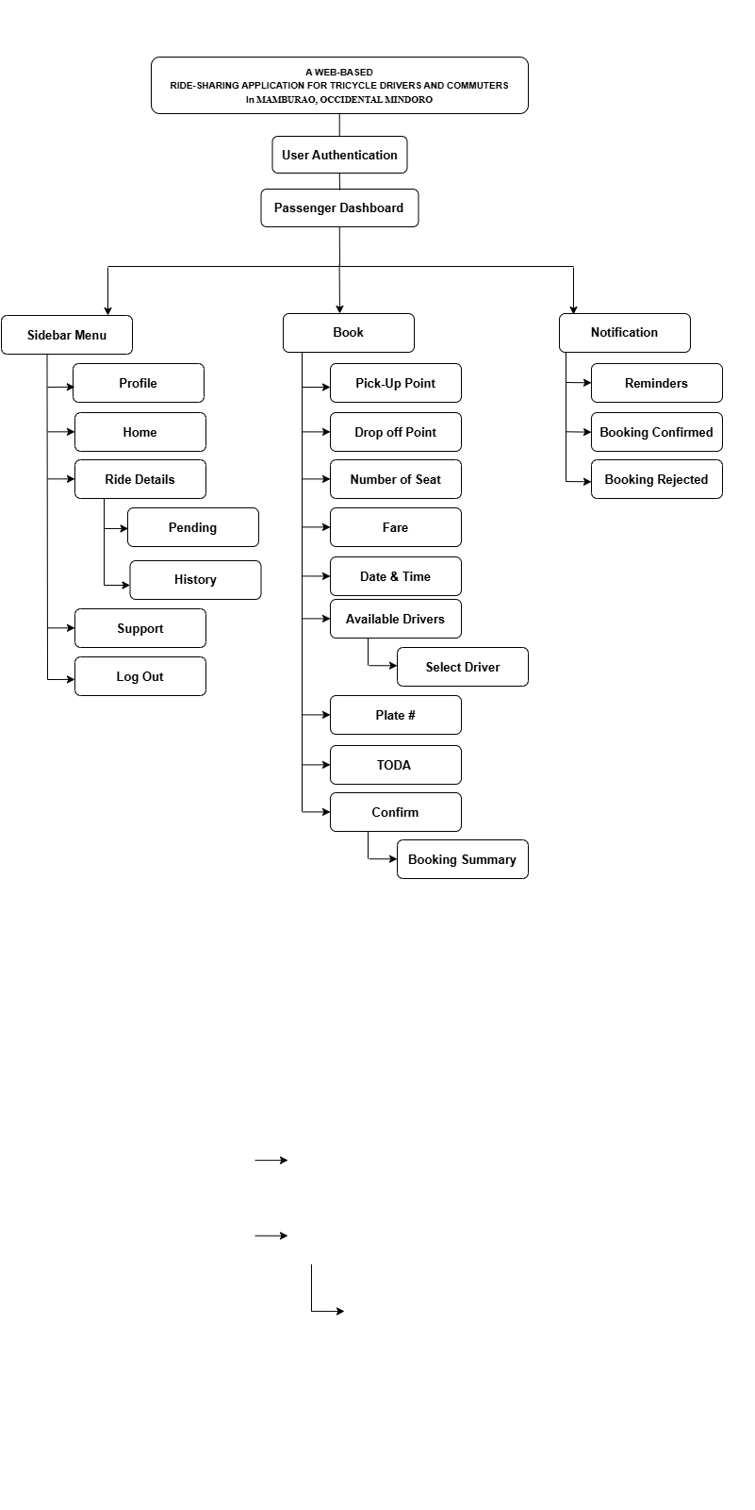

Fig. 2. The hierarchical diagram for the passenger interface.

The development of MAMBYAHE: A Web-Based Ride-Sharing Application for Tricycle Drivers and Commuters in Mamburao, Occidental Mindoro aims to transform the traditional tricycle transportation process through a centralized digital platform. The system serves as a bridge between commuters and tricycle drivers, allowing passengers to request rides conveniently and securely. In addition to regular users, the application integrates administrative roles such as the chairman of each Tricycle Operators and Drivers Association (TODA) and the Municipal Transportation Franchising and Regulatory Board (MTFRB). Each TODA chairman is provided with an interface to monitor their members, manage trip assignments, and manually dispatch rides for walk-in or unbooked passengers. The MTFRB, meanwhile, has access to a comprehensive dashboard that enables them to oversee all drivers, trip activities, passenger logs, and submitted reports, ensuring that transport regulations are properly enforced.

The system provides distinct, role-specific functionalities for each type of user: passenger, driver, TODA chairman, and MTFRB administrator. Passengers are able to book rides by specifying pick-up and drop-off points, selecting available drivers, and reviewing fare estimates. Drivers can view incoming ride requests, accept or decline bookings, and access a history of completed trips. A mutual feedback mechanism allows both drivers and passengers to rate and review each other after a trip, thereby encouraging better service and accountability. Moreover, both parties have the ability to submit reports regarding issues encountered during rides. TODA chairmen can monitor all drivers within their association, dispatch rides manually when necessary, and access reports for resolution. The MTFRB’s interface supports centralized monitoring of all stakeholders, ensuring compliance with local transport policies and enabling data-driven regulatory decisions.

The system follows a role-based, modular design where users gain access to specific dashboards upon authentication. Passengers initiate bookings by submitting ride details, which are processed in real time to display available drivers or, in special cases, are handled manually by the TODA chairman. Ride confirmations are communicated through the system’s notification module, which updates both the driver and passenger. Upon completion of each trip, the platform activates feedback and reporting modules to gather evaluations and concerns. All data, ranging from booking logs to user-submitted feedback—is recorded and made accessible to authorized parties such as TODA chairmen and the MTFRB for verification and review. This structure ensures operational efficiency, enhances transparency, and enforces validation procedures that are essential for reliable and regulated ride-sharing services in the local context.

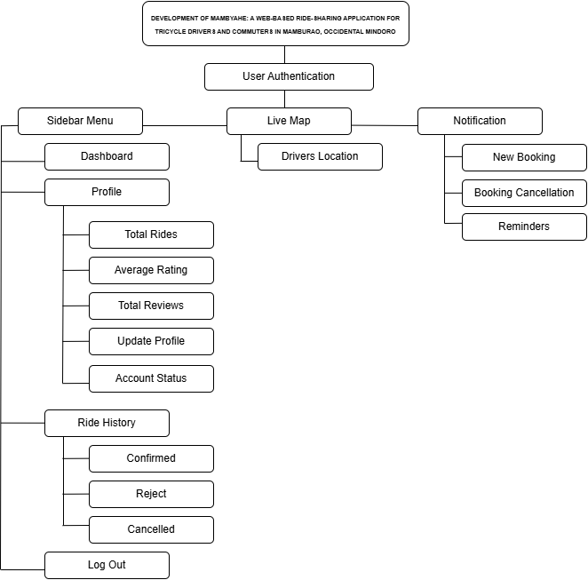

Fig. 3. The structure of the web-based portal for drivers account.

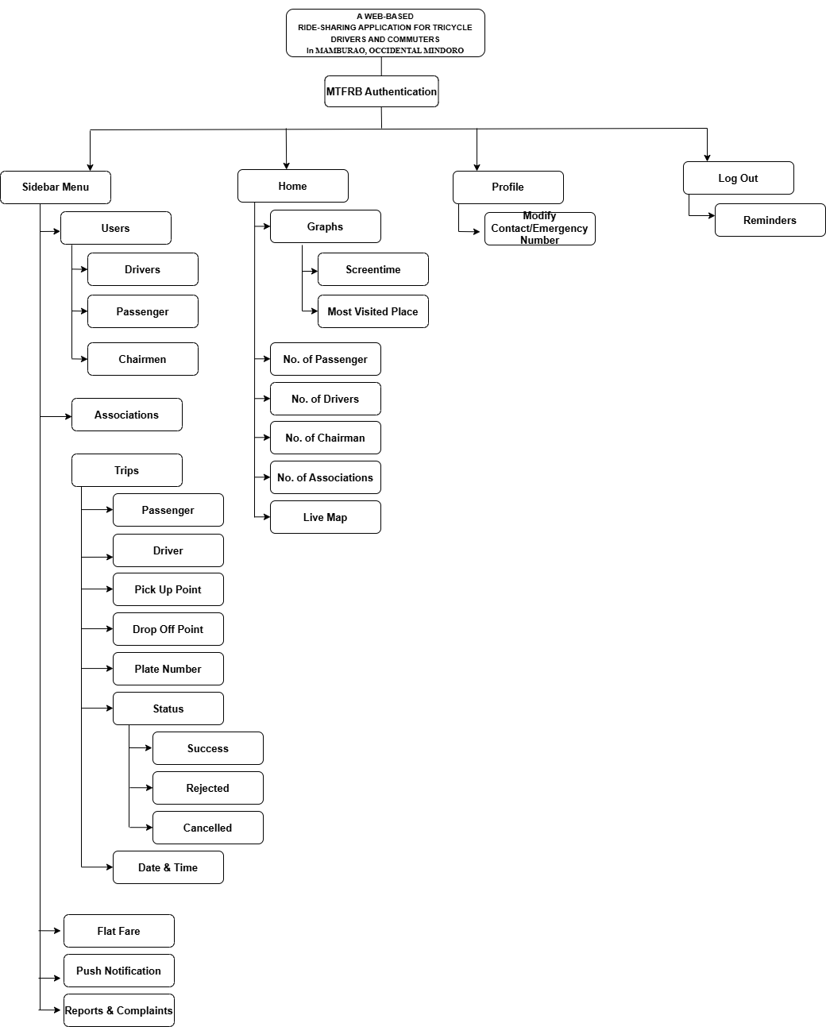

Fig. 4. The structure of the web-based portal for MTFRB account.

**Project Development**

The Agile model was used in the system project development process of the study. The following are the phases that were done during the development: planning, design, development, testing, deployment, review, and launch.

**Planning.** During this phase, the researchers collected all necessary data from clubs and organizations such as identifying the necessary user information for attendance and payment features. The researchers gathered information from research publications related to the study and the expectations and requirements was defined.

**Designing.** Creating the user interface and designing the general architecture of the web app is part of this process. The researchers created wireframes and mockups of the user interface. Several factors was considered to ensure that the application’s design is user-friendly.

**Develop.** The development phase started after the design is completed. In this process, the coding and putting the elements mentioned in the design phase into action was built.

**Testing.** To guarantee that the web app works as intended, testing was done which includes the unit and user acceptability testing. At this step, the developed system undergo several trials such as running on multiple resolutions, platforms, and further testing in order for the developers to know what changes need to be made.

**Deployment.** The system was tested at this stage for the researchers to learn about the user’s perspective. The researchers picked certain users to test the system. After testing is completed, the web app was deployed to a production environment. This comprises installing the necessary infrastructure and getting the application ready for launch.

**Review.** Following the deployment, the researchers conducted a review to determine the project's success from the users. Gathering input and reviews from the users was considered by the proponents in identifying areas for improvement was part of this process.

**Launch.** Following a series of tests, deployment, and the researchers consideration of all user reviews, the web app was made available to the public and the target users.

**Project Structure**

This section shows the Mambyahe application overall passenger user interface.

Figure 5 shows the “Login” page of the web-app. Users are redirected to the application login page after accessing the link.

Fig. 4. Login page of the web-app.

Newly created account will be redirected on pages shown in figure 6. Users are redirected to the application homepage after logging in.

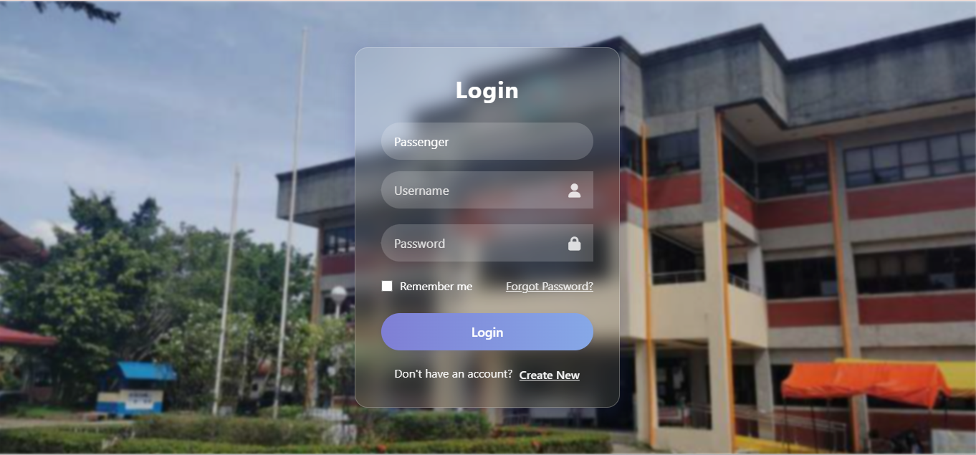

Fig. 5. Home page of the web-app.

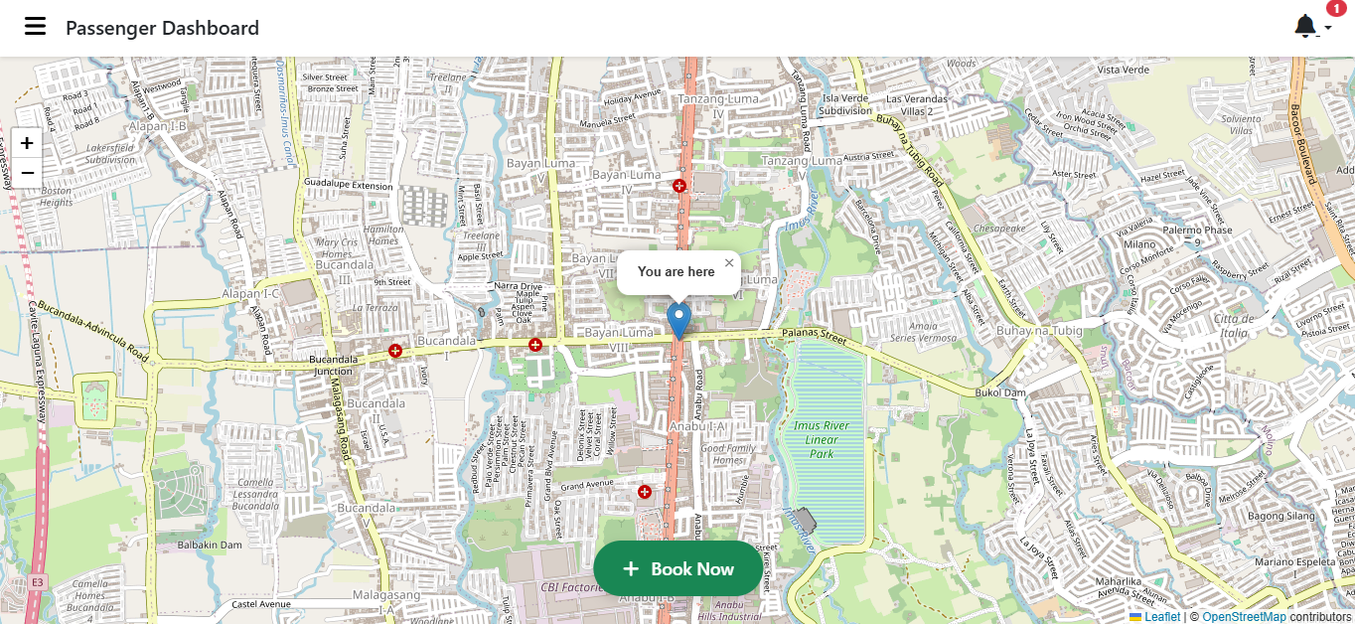

Figure 6 shows the sidebar menu of the web app. Users can either view and update their profile, track their past bookings, view the contact information of the MTFRB or log out their aaccount.

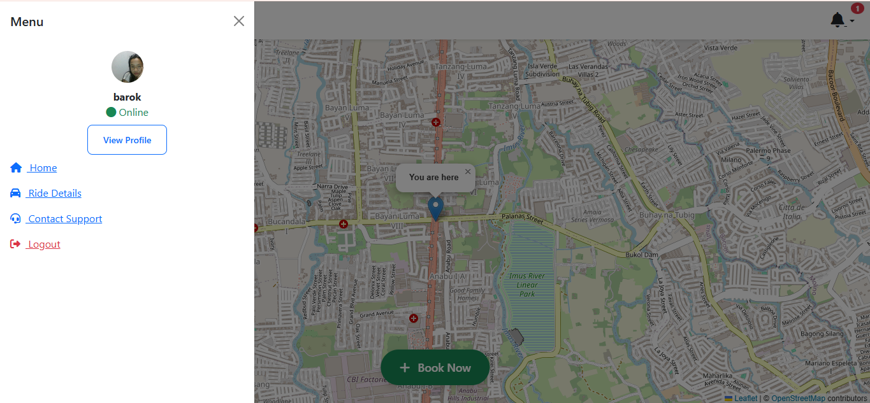

Fig. 6. Sidebar menu of the web-app.

Figure 7 shows the passengers profile page of the web app when the user clicked it inside the sidebar menu.

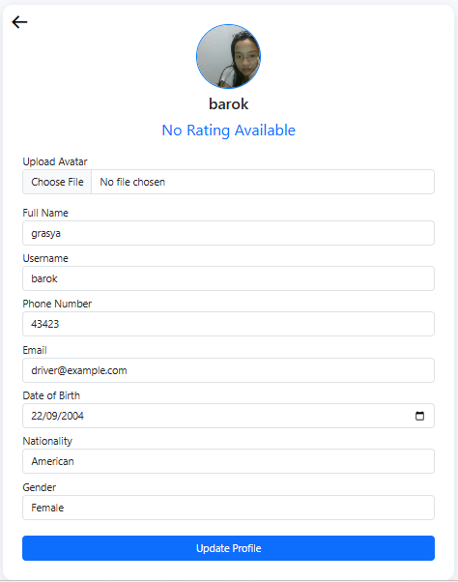

Fig. 7 Passenger profile page of the web-app.

Figure 8shows the passengers ride history of the web app. Users can choose from the listed groups to join.



Fig. 4. Book rides page of the web-app.

Figure 9 shows the bookings of the web app. Users can choose from the listed groups to join.

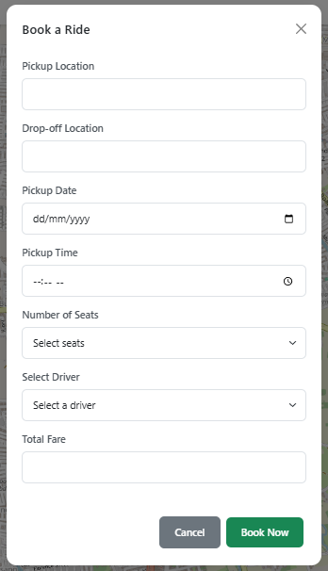

Fig. 9. Support page of the web-app.

Figure 10 shows the rejection page of the web app. Users can view the reasons and on the same time can send a complaint to the admin, the MTFRB.

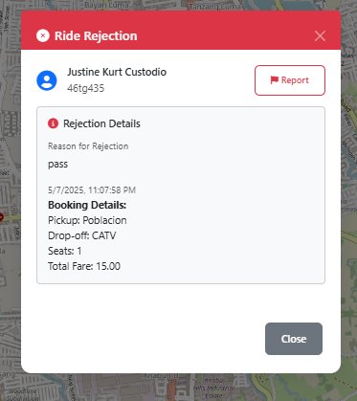

Figure 10 shows the reviews and feedback page of the web app. Users can view the reviews that they can get from the drivers.



Fig. 11. Reviews and Feedback page of the web-app.

Figure 12 shows the reviews and feedback page of the web app. Users can view the reviews that they can get from the drivers.

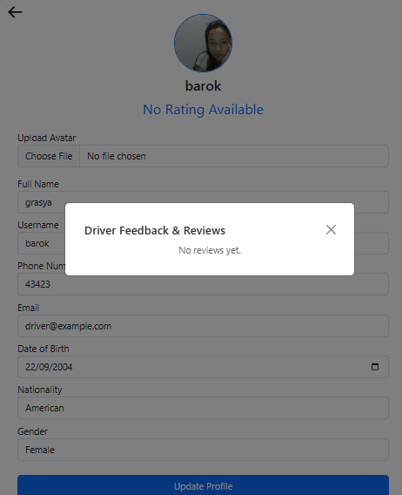

Fig. 13. of the web-app.

Figure 14 shows the “homepage” of the web app when the user already created an account.

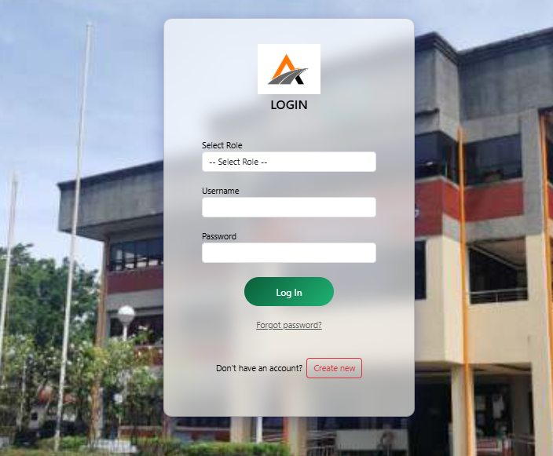

Fig. 14. Hompage menu of the web-app.

Figure 15 shows the drivers homepage of the web app.

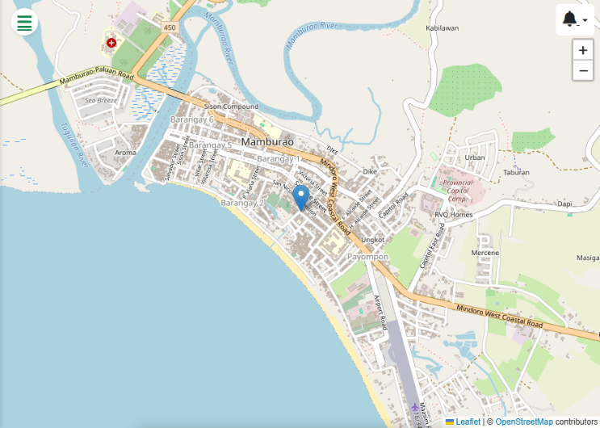

Fig. 15. Notification page of the web-app.

Figure 16 shows the notification page of the web app.

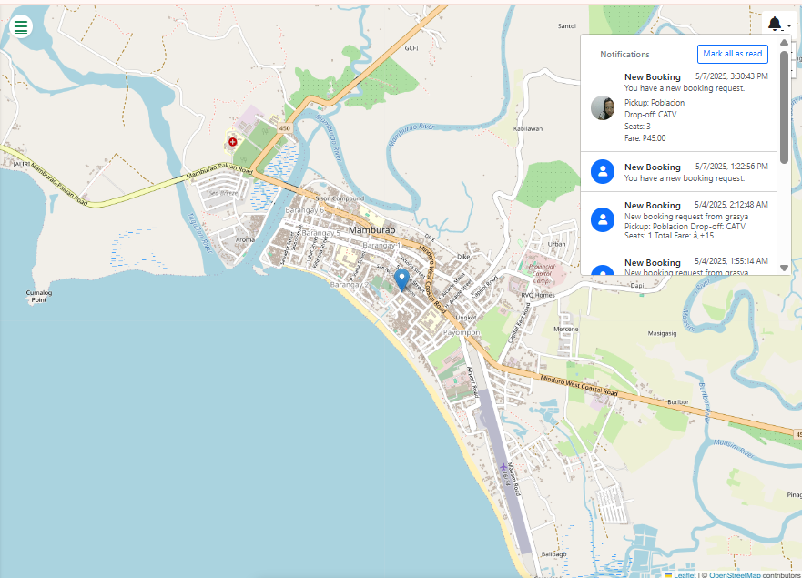

Fig. 16. Confirmation modal of the web-app.

Figure 17 shows the ride confirmation modal page of the web app when the driver clicked the notification.

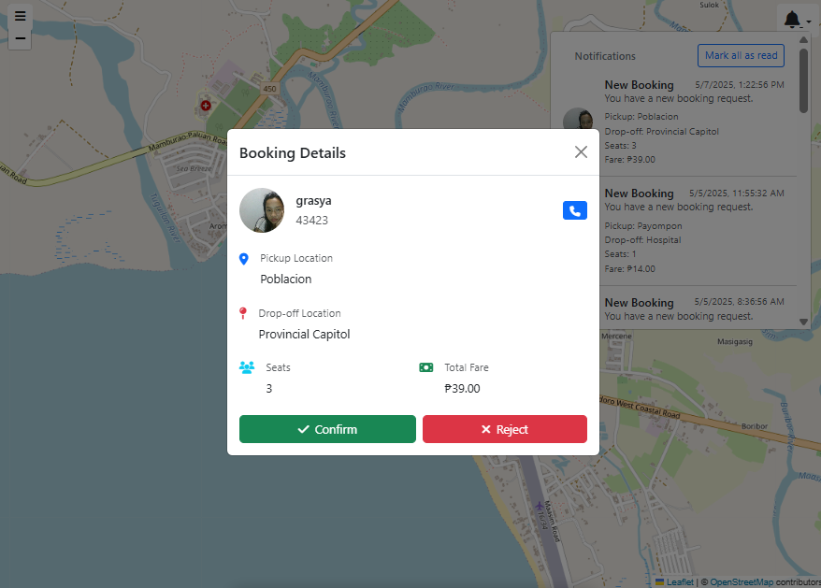

Fig. 17. Confirmation modal of the bookings..

Figure 18 shows the bottom sheet ride info page of the web app. When the drivers clicked the arrive button, that means they arrived at the destination point.

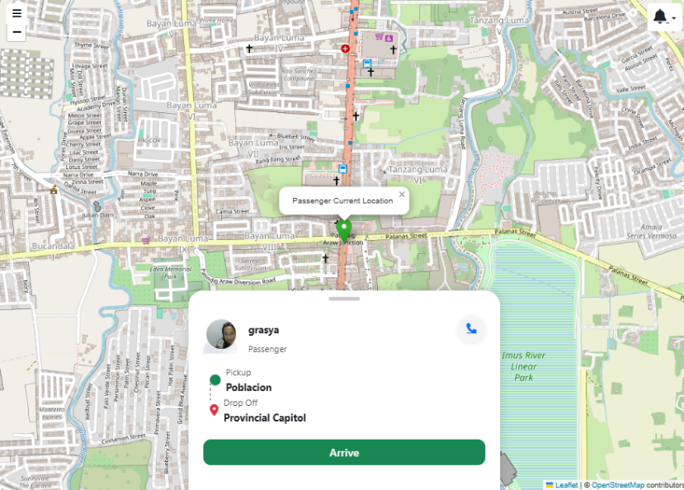

Fig. 18. Hompage menu of the web-app.

Figure 19 shows the drivers can able to rate the passengers according to the passenger’s behavior.

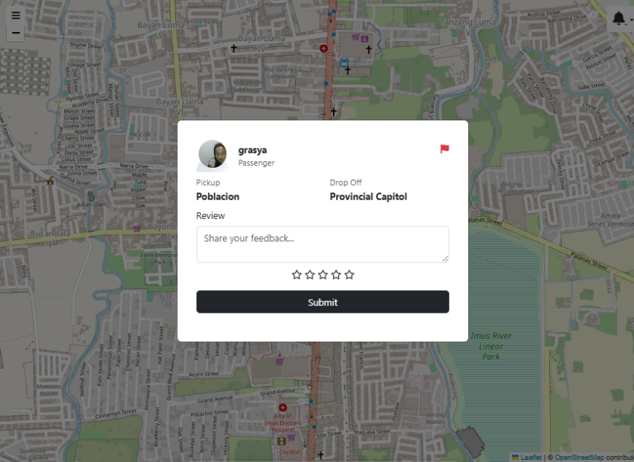

Fig. 19. Reviews and feedback page of the web-app.

Figure 20 shows the complaint page of the web app when the drivers can able to complain the passenger.

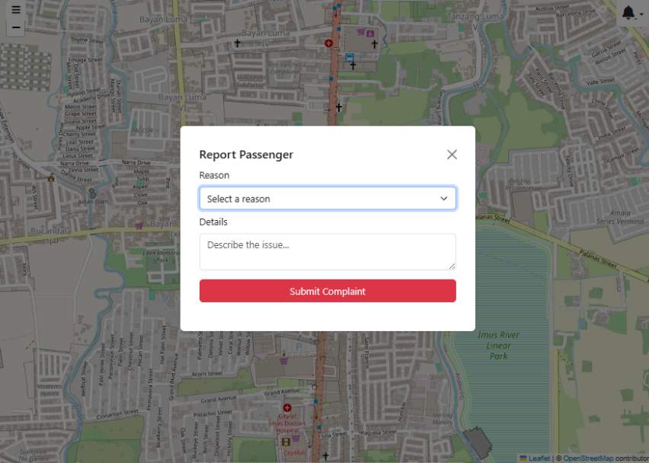

Fig. 20. Complaint page of the web-app.

Figure 21 shows the passengers profile page of the web app when the user clicked it inside the sidebar menu.

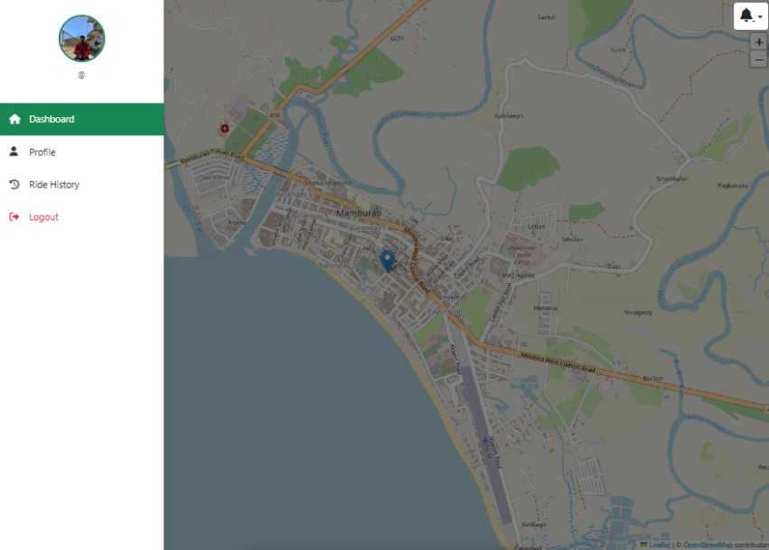

Fig. 21. Sidebar menu of the web-app.

Figure 22 shows the sidebar menu page of the web app.

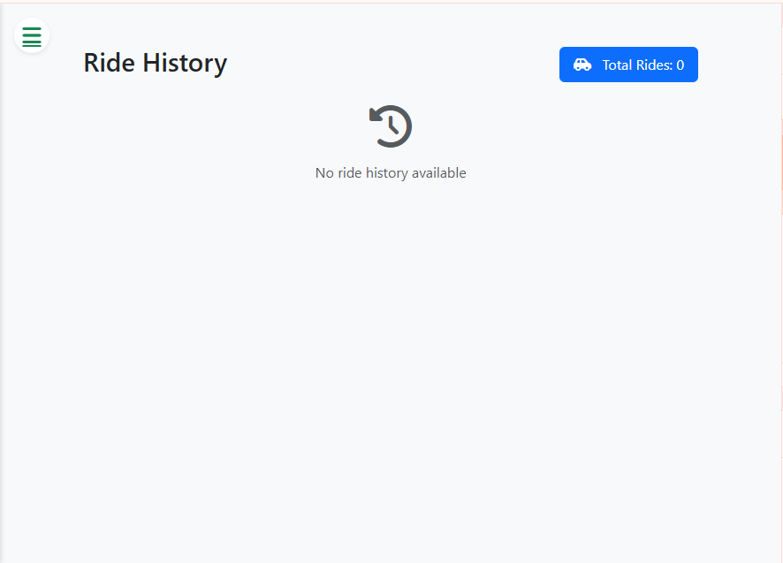

Fig. 22. Ride History of the web-app.

Figure 23 shows the drivers profile page of the web app when the user clicked it inside the sidebar menu.

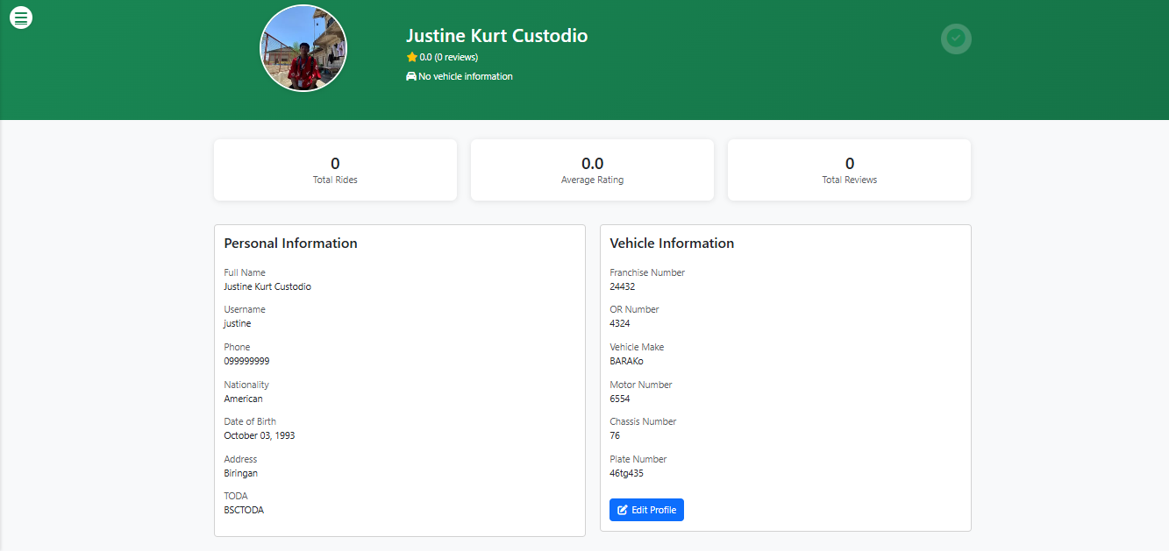

Fig. 23. Drivers profile of the web-app.

**REFERENCES**

Ali, B. J., Gardi, B., Othman, B. J., Ahmed, S. A., Ismael, N. B., Hamza, P. A., Aziz, H. M., Sabir, B. Y., Sorguli, S., & Anwar, G. (2021). Hotel service quality: The impact of service quality on customer satisfaction in hospitality. *International Journal of Engineering, Business and Management*, 5(3), 14–28. <https://doi.org/10.22161/ijebm.5.3.2>

Ali, G., Dida, M. A., & Elikana Sam, A. (2021). A secure and efficient multi-factor authentication algorithm for mobile money applications. *Future Internet*, 13(12), 299. <https://doi.org/10.3390/fi13120299>

Alavi, A., Khosravi, A., & Khatami, S. (2021). Indoor positioning systems: Challenges and solutions. *Journal of Location Based Services*, 15(1), 1-15.

Alzubaidi, L., Zhang, J., Liu, Y., & Hamed, O. (2020). Multi-factor authentication in mobile applications: A case study of ride-sharing apps. *Journal of Cybersecurity, 5*(2), 15–30.

Anahid Basiri, Lohan, E. S., Moore, T., Winstanley, A., Peltola, P., Hill, C., Amirian, P., & Figueiredo, P. (2017). Indoor location based services challenges, requirements and usability of current solutions. *Computer Science Review*, 24, 1–12. <https://doi.org/10.1016/j.cosrev.2017.03.002>

Barrueco, J. M. (2015). Transportation Research Part A: Policy and Practice / Elsevier. *Repec.org*. <https://citec.repec.org/s/2023/eeetransa>

Bernhaupt, R.. (2017). Evaluating User Experience in Games - Concepts and Methods.

Brun, F.., Massimi, L.., Fratini, M.., Dreossi, D.., Billè, F.., Accardo, A.., Pugliese, R.., & Cedola, A.. (2017). SYRMEP Tomo Project: a graphical user interface for customizing CT reconstruction workflows. *Advanced Structural and Chemical Imaging* , 3 .

Chen, Jieshan., Xie, Mulong., Xing, Zhenchang., Chen, Chunyang., Xu, Xiwei., Zhu, Liming., & Li, Guoqiang. (2020). Object detection for graphical user interface: old fashioned or deep learning or a combination?. *Proceedings of the 28th ACM Joint Meeting on European Software Engineering Conference and Symposium on the Foundations of Software Engineering* .

Chen, Y., & Lee, T. (2022). Compliance frameworks and organizational resilience. *Journal of Business Ethics*, 171(3), 567-582.

Dytckov, S., Persson, J. A., Lorig, F., & Davidsson, P. (2022). Potential benefits of demand responsive transport in rural areas: A simulation study in Lolland, Denmark. *Sustainability*, 14(6), 3252.

Edler, Daniel., Klein, Johannes., Antonelli, A.., & Silvestro, D.. (2020). raxmlGUI 2.0: A graphical interface and toolkit for phylogenetic analyses using RAxML. *Methods in Ecology and Evolution* , 12 , 373 - 377 .

Gao, Y., Zhang, L., Patel, R., & Kim, J. (2021). User experience and security in mobile applications: A study of ride-sharing services. *International Journal of Human-Computer Interaction, 37*(4), 345–358.

Garcia, M. (2023). A comparative analysis of international compliance standards and organizational performance in audits. *Journal of Compliance and Regulatory Affairs*, 12(1), 45-60. <https://doi.org/10.1234/jcra.2023.0012>

Hossain, Jamil., Hassan, Anees Ul., Bilal, Hafiz Muhammad., Ali, Rahman., Afzal, Muhammad., Hussain, Shujaat., Bang, Jaehun., Baños, O.., & Lee, Sungyoung. (2018). Model-based adaptive user interface based on context and user experience evaluation. *Journal on Multimodal User Interfaces* , 12 , 1 - 16 .

Johnson, P. (2016). Challenges faced by SMEs in regulatory compliance. *Small Business Economics*, 46(2), 273-288.

Kelter, Riko. (2020). Bayesian alternatives to null hypothesis significance testing in biomedical research: a non-technical introduction to Bayesian inference with JASP. *BMC Medical Research Methodology* , 20 .

Kim, S., et al. (2023). Predictive analytics in real-time location tracking: Opportunities and challenges. *Journal of Data Science and Analytics*.

Khodani Netshifhefhe, Magalane Vivian Netshifhefhe, Munashe Naphtali Mupa, & Murapa. (2024). Integrating internal auditing and legal compliance: A strategic approach to risk management. *ResearchGate*, 8(4), 446–465. <https://www.researchgate.net/publication/385318623_Integrating_Internal_Auditing_and_Legal_Compliance_A_Strategic_Approach_to_Risk_Management>

Kumar, S., & Singh, R. (2021). Regulatory engagement and compliance strategies. *International Journal of Business Governance*, 15(4), 350-368.

Leovigildo Lito Mallillin, D Mallillin, Banaag, A. G., & Carag, E. (2020). Commuter behaviour in public transport and their implications to policies and optimal use. *Journal of Social Sciences and Humanities*, 6(1-2020), 29–38. <https://www.researchgate.net/publication/343097235_Commuter_behaviour_in_public_transport_and_their_implications_to_policies_and_optimal_use>

Li, Y., Wang, X., Chen, Z., & Zhang, K. (2024). Machine learning for database performance optimization. *Database Systems Journal, 21*(1), 45-67.

Liu, H., Martinez, R., Park, S., & Johnson, T. (2022). Smart city traffic management using GPS-enabled real-time location tracking. *Urban Computing Journal, 8*(3), 112-135.

Marvel, Skylar W.., To, Kimberly., Grimm, Fabian A.., Wright, F.., Rusyn, I.., & Reif, David M.. (2018). ToxPi Graphical User Interface 2.0: Dynamic exploration, visualization, and sharing of integrated data models. *BMC Bioinformatics* , 19 .

Miller, J., & Jentz, G. (2019). Organizational integrity and compliance. *Ethics & Compliance Journal*, 12(2), 101-115.

Mohan, S., Gupta, P., Sharma, A., & Lee, J. (2020). Performance evaluation of cloud DBMS. *Journal of Cloud Technology, 15*(2), 112-130.

Mohammad, Taj., Mathur, Yash., & Hassan, M.. (2020). InstaDock: A single-click graphical user interface for molecular docking-based virtual high-throughput screening. *Briefings in bioinformatics* .

Osorio-Olvera, Luis., Osorio-Olvera, Luis., Lira‐Noriega, A.., Soberón, Jorge., Peterson, A.., Falconi, M.., Contreras-Díaz, Rusby G.., Martínez‐Meyer, E.., Barve, V.., & Barve, N.. (2020). ntbox: An r package with graphical user interface for modelling and evaluating multidimensional ecological niches. *Methods in Ecology and Evolution* , 11 , 1199 - 1206 .

Oulasvirta, Antti., Dayama, N.., Shiripour, Morteza., John, Maximilian., & Karrenbauer, Andreas. (2020). Combinatorial Optimization of Graphical User Interface Designs. *Proceedings of the IEEE* , 108 , 434-464 .

Patel, R., Lee, S., Gupta, A., & Wang, Y. (2023). AI in database management: Current trends and future directions. *AI & Data Science Journal, 12*(4), 78–95.

Pettersson, Ingrid., Lachner, F.., Frison, Anna-Katharina., Riener, A.., & Butz, A.. (2018). A Bermuda Triangle?: A Review of Method Application and Triangulation in User Experience Evaluation. *Proceedings of the 2018 CHI Conference on Human Factors in Computing Systems* .

Privacy concerns rise amid surveillance and data regulation. (2025). *The Pinnacle Gazette*. <https://evrimagaci.org/tpg/privacy-concerns-rise-amid-surveillance-and-data-regulation-336269#:~:text=The%20ongoing%20discussions%20around%20personal%20data%20protection,safeguard%20individual%20rights%20in%20the%20digital%20age>.

Priyam, Anurag., Woodcroft, Bennet., Rai, Vivek., Munagala, Alekhya., Moghul, Ismail., Ter, F.., Gibbins, M.., Moon, HongKee., Leonard, G.., Rumpf, Wolfgang., & Wurm, Y.. (2019). Sequenceserver: A Modern Graphical User Interface for Custom BLAST Databases. *Molecular Biology and Evolution* , 36 , 2922 - 2924 .

Reyal, Shyam., Zhai, Shumin., & Kristensson, P.. (2015). Performance and User Experience of Touchscreen and Gesture Keyboards in a Lab Setting and in the Wild. *Proceedings of the 33rd Annual ACM Conference on Human Factors in Computing Systems* .

Roberts, M. (2018). Building effective compliance programs. *Corporate Governance Review*, 24(3), 219-234.

Ruijten, Peter A. M.., Terken, J.., & Chandramouli, S.. (2018). Enhancing Trust in Autonomous Vehicles through Intelligent User Interfaces That Mimic Human Behavior. *Multimodal Technol. Interact.* , 2 , 62 .

Saket, B.., Endert, A.., & Stasko, J.. (2016). Beyond Usability and Performance: A Review of User Experience-focused Evaluations in Visualization. , 133-142 .

Sergei Dytckov, Persson, J. A., Lorig, F., & Davidsson, P. (2022). Potential benefits of demand responsive transport in rural areas: A simulation study in Lolland, Denmark. *Sustainability*, 14(6), 3252.

Singh, P., Zhang, L., Patel, R., & Kumar, N. (2023). Security challenges in modern database systems. Journal of Cybersecurity, 5(2), 145–160.

Smith, A., & Brown, L. (2020). Globalization and compliance complexity. *International Regulatory Review*, 8(4), 45-60.

Smith, L., & Jones, K. (2021). Phishing and account takeover in ride-sharing applications: A growing concern. *Journal of Digital Security*, 9(2), 99-115.

Stonebraker, M., Cetintemel, U., & Zdonik, S. (2018). The evolution of database systems. *ACM Computing Surveys, 51*(3), Article 42.

Sundar, S.., Xu, Qian., & Bellur, Saraswathi. (2017). Designing interactivity in media interfaces: a communications perspective. *Proceedings of the SIGCHI Conference on Human Factors in Computing Systems* .

Vance, Anthony., Lowry, P.., & Eggett, D.. (2015). Increasing Accountability Through User-Interface Design Artifacts: A New Approach to Addressing the Problem of Access-Policy Violations. *MIS Q.* , 39 , 345-366 .

Vermeeren, A.., Law, E.., Roto, Virpi., Obrist, Marianna., Hoonhout, J.., & Väänänen, Kaisa. (2017). User experience evaluation methods: current state and development needs. , 521-530 .

Zaharia, M., Xin, R. S., Wendell, P., Das, T., Armbrust, M., Dave, A., Meng, X., Rosen, J., Venkataraman, S., Franklin, M. J., Ghodsi, A., Gonzalez, J., Shenker, S., & Stoica, I. (2016). NewSQL databases: A new era. *IEEE Transactions on Cloud Computing, 4*(2), 123-135.

Zhang, X., Wang, Y., Su, Z., Xing, R., Liu, D., Luan, T. H., & Shen, X. (2022). A survey on metaverse: fundamentals, security, and privacy. *IEEE Communications Surveys & Tutorials*, *25*(1), 319–352

Zhao, X., Wang, J., & Liu, X. (2020). Hybrid systems for real-time location tracking: A review. *Sensors*, 20(12), 1-20.